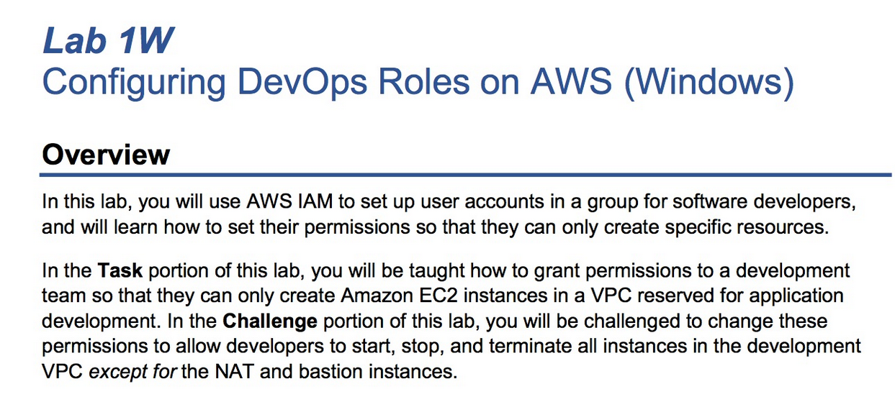 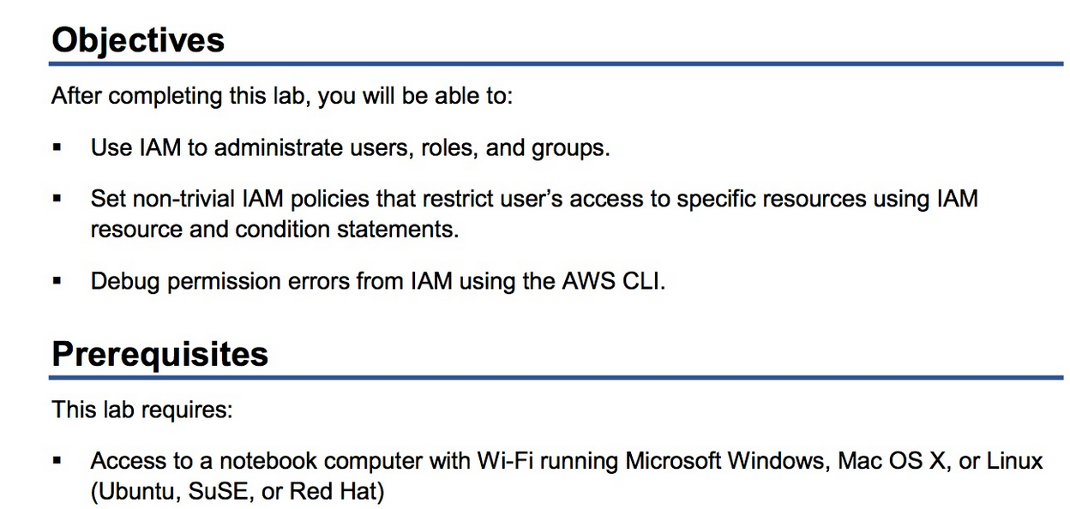 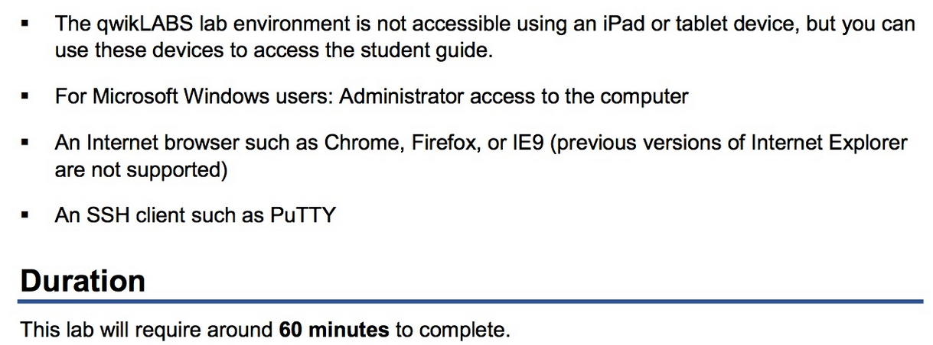 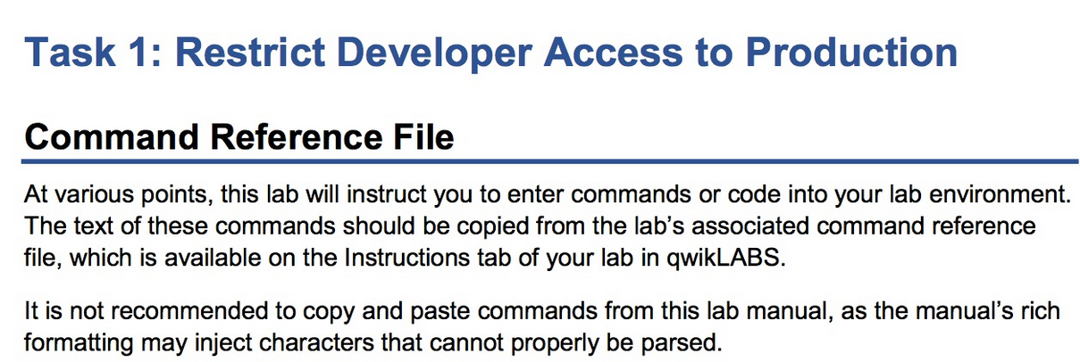 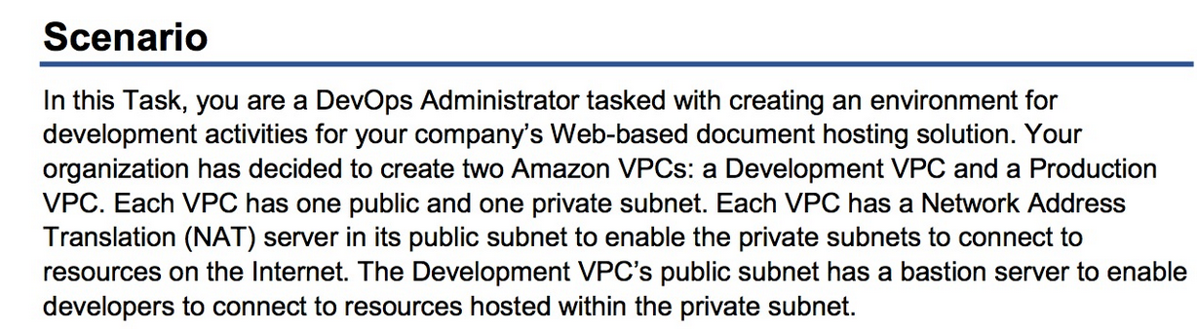 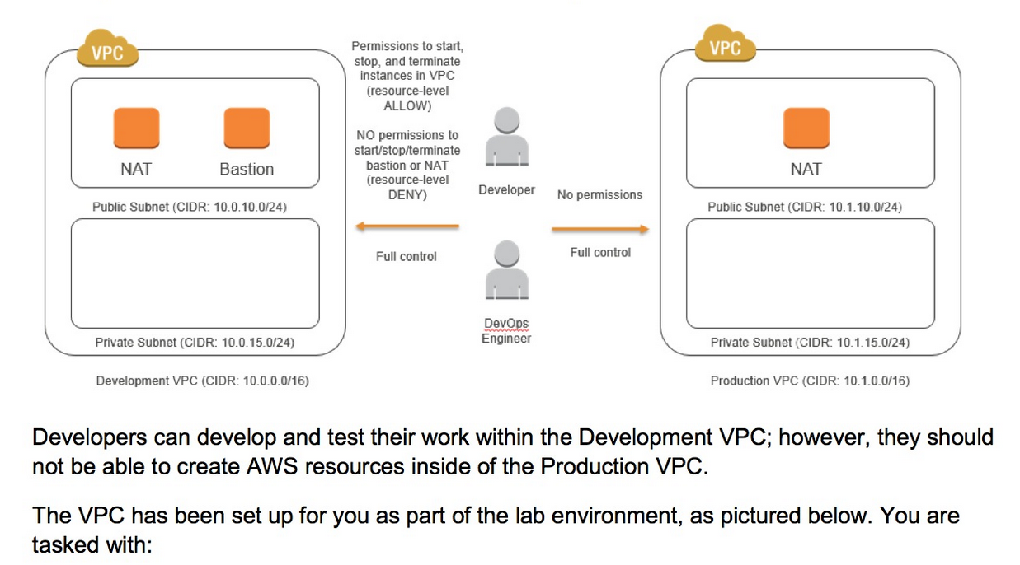 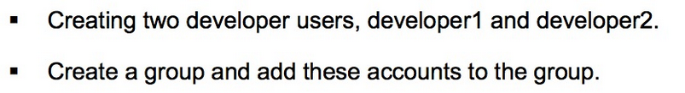 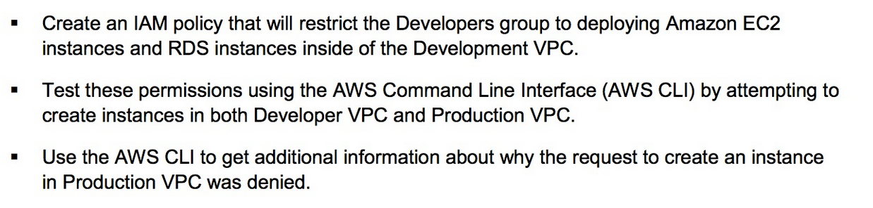 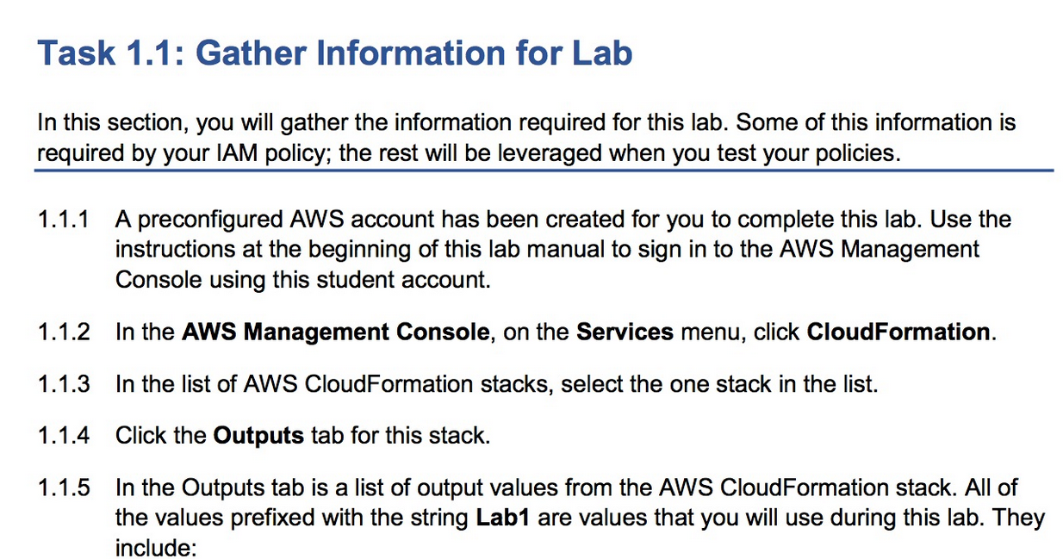 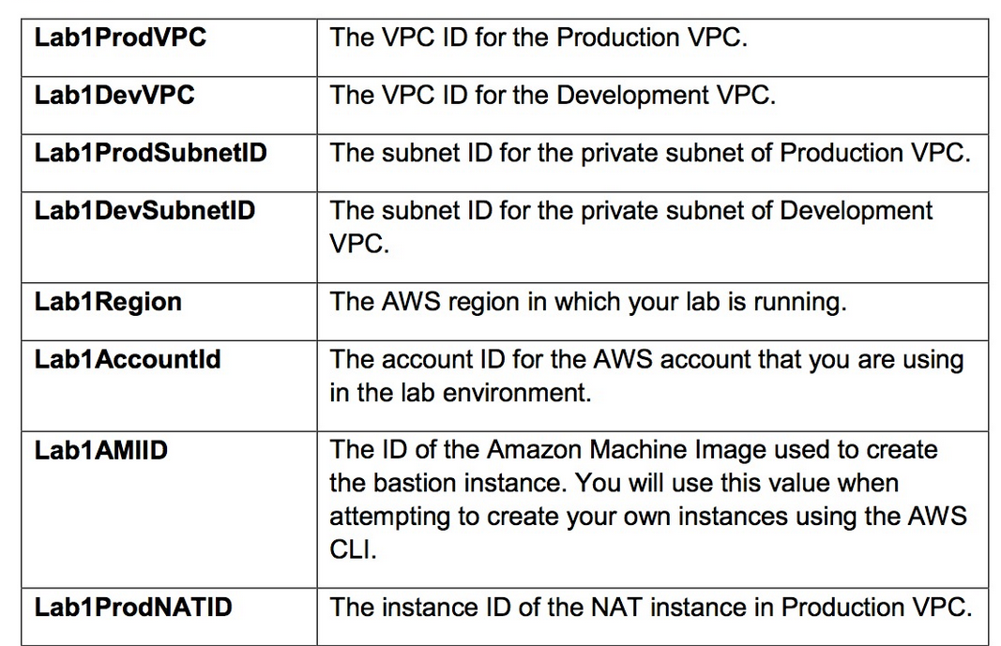 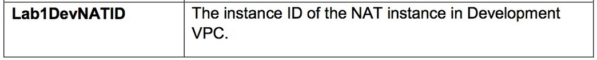



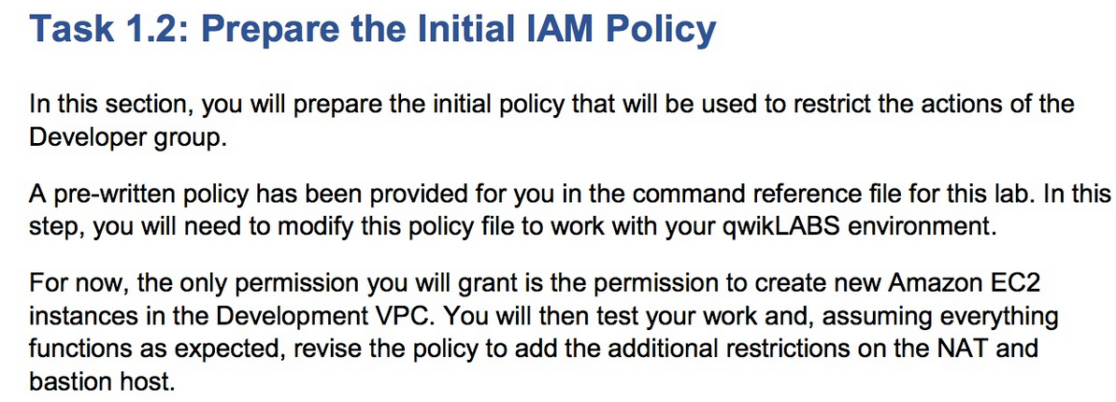 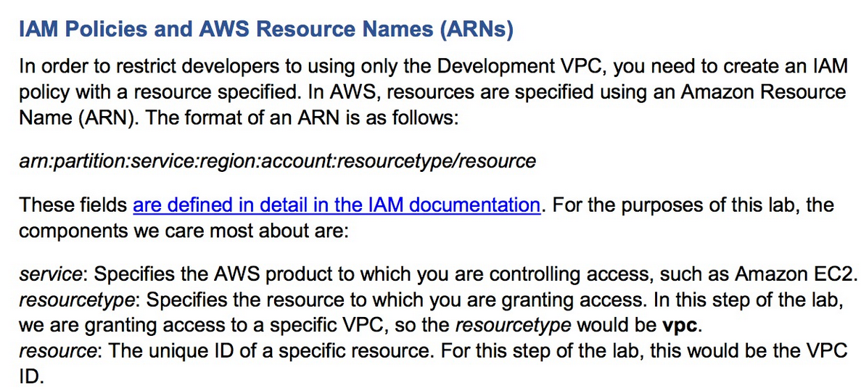 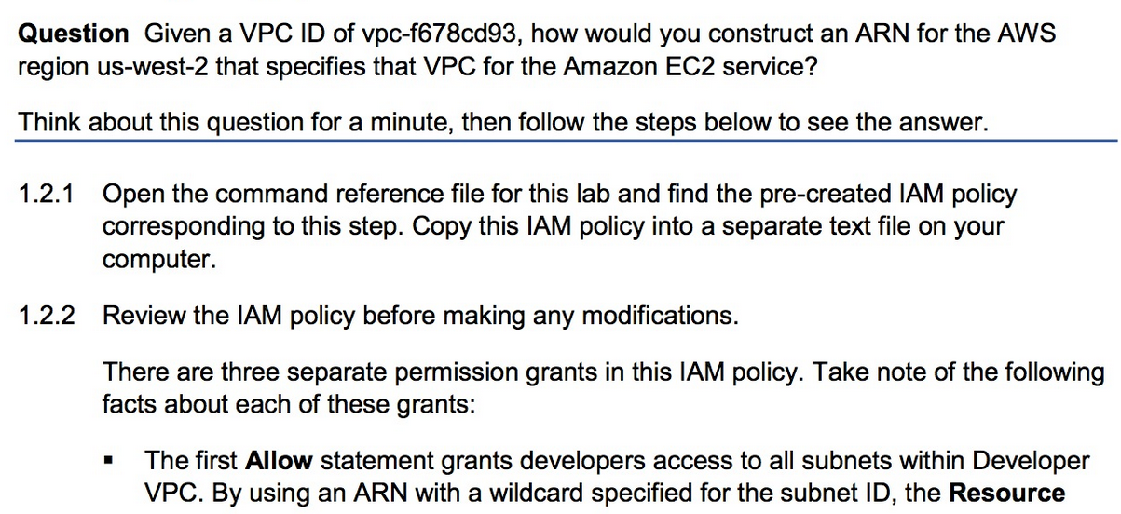 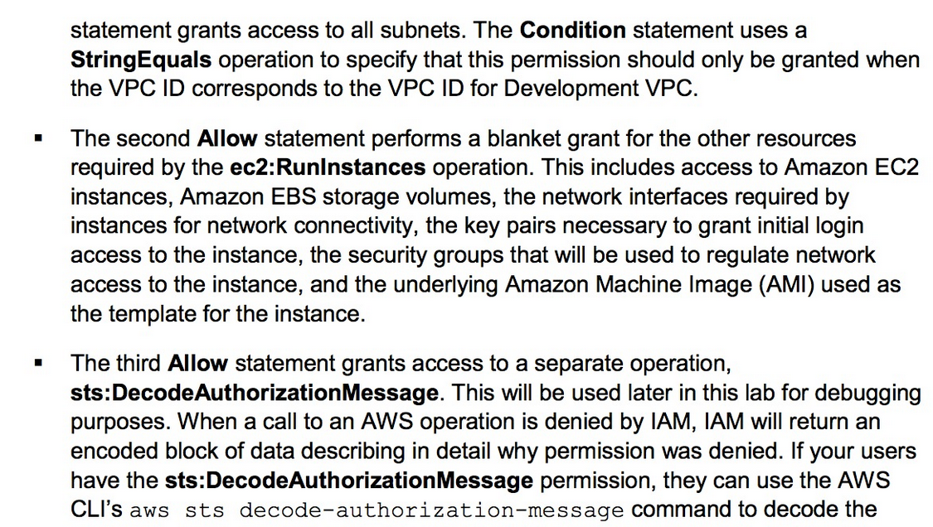 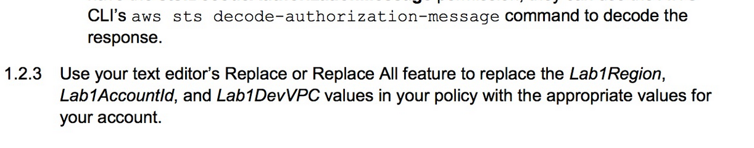

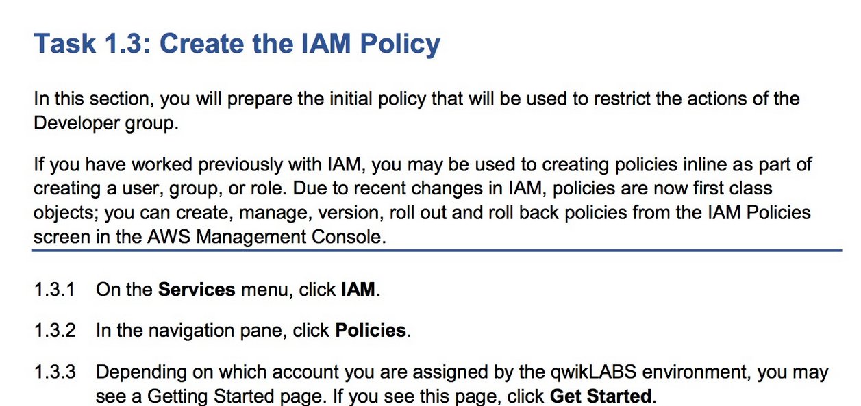 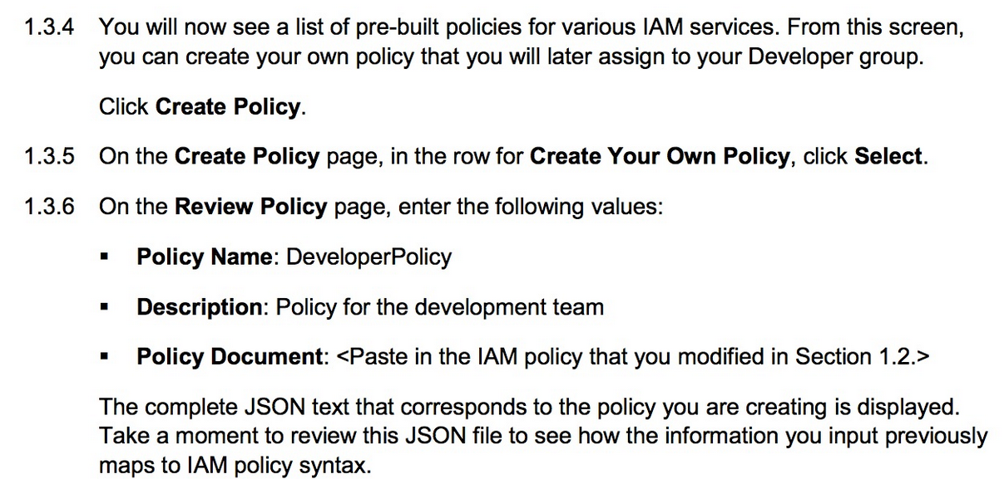 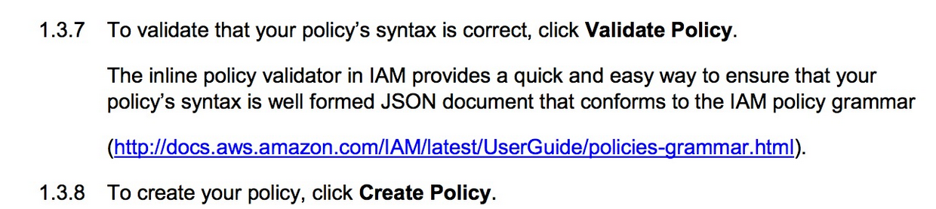 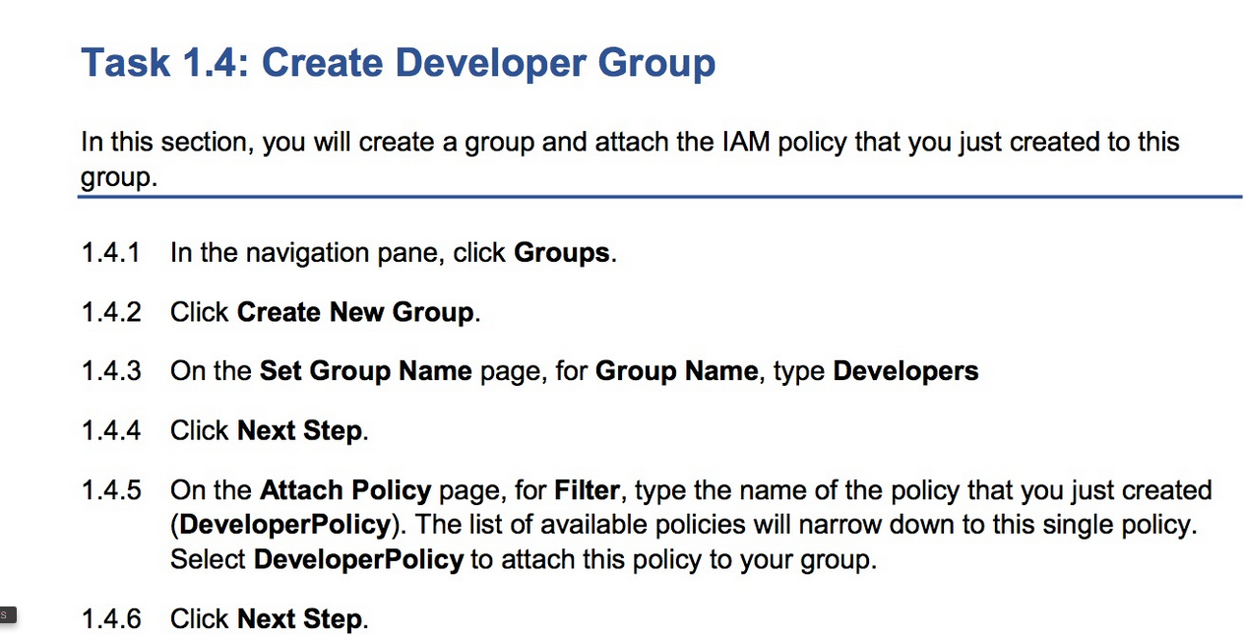 

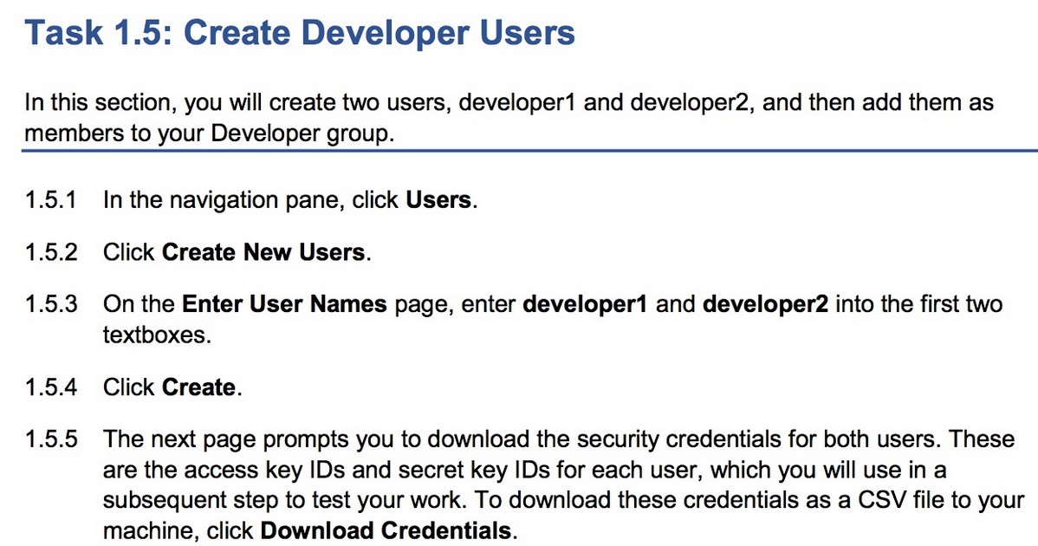 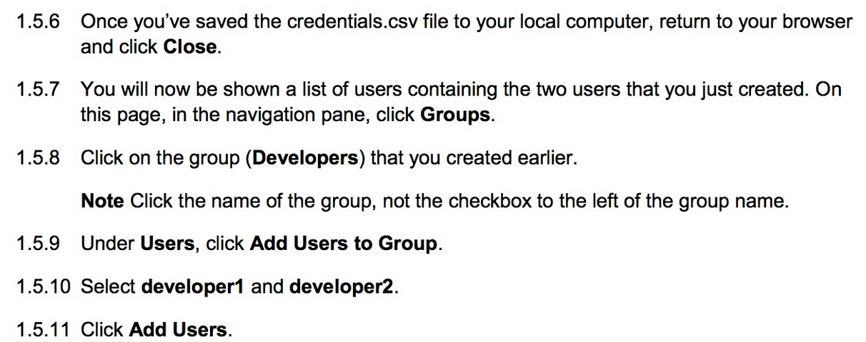 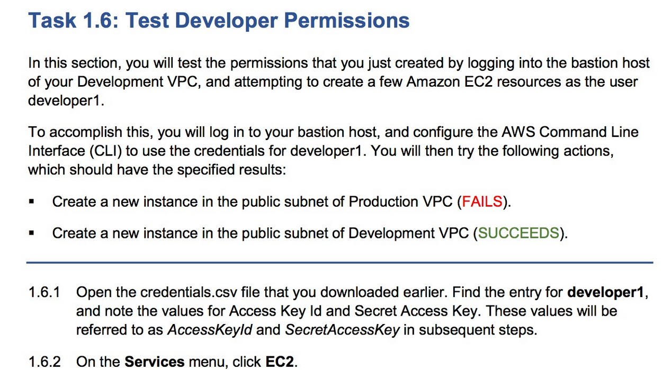 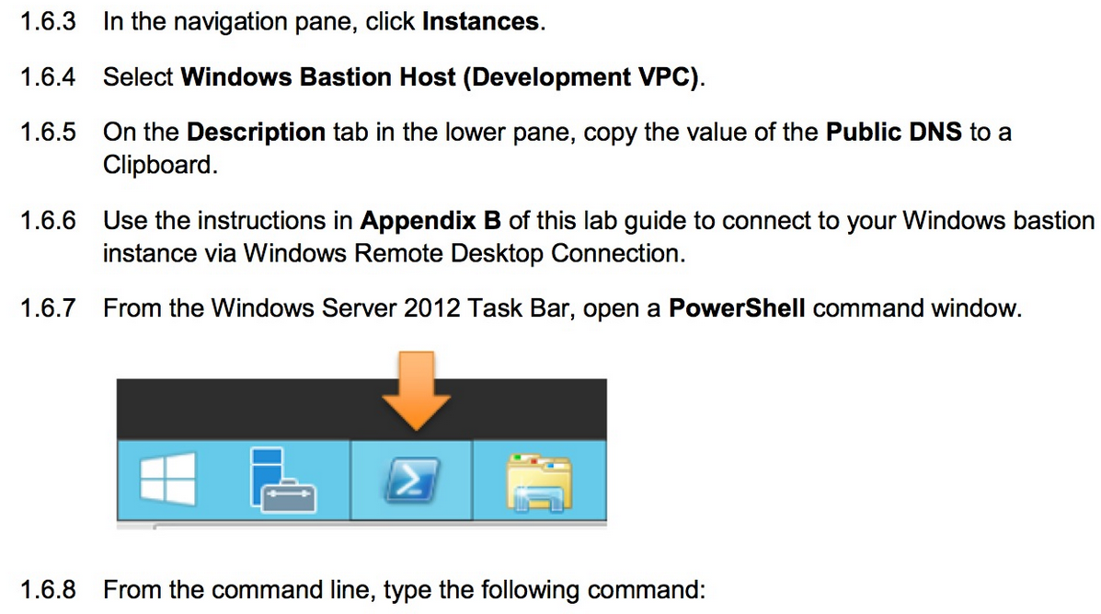 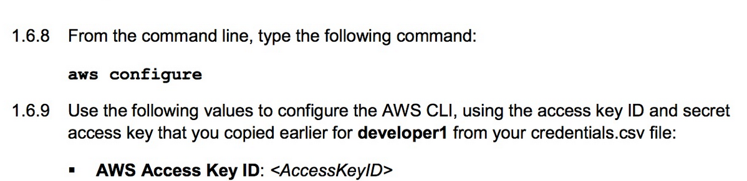 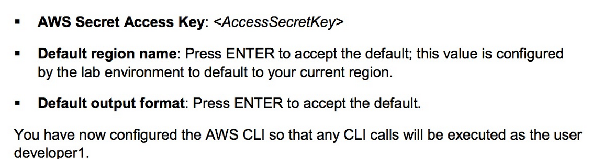 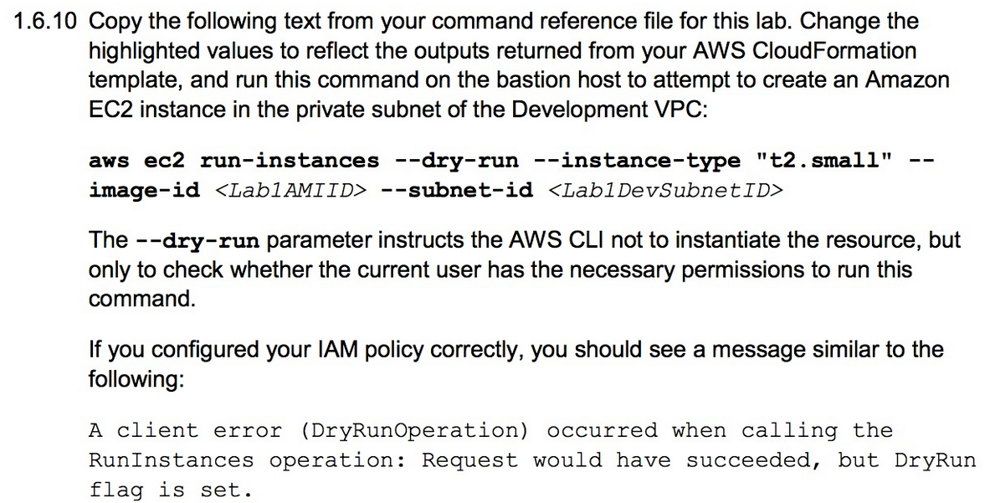  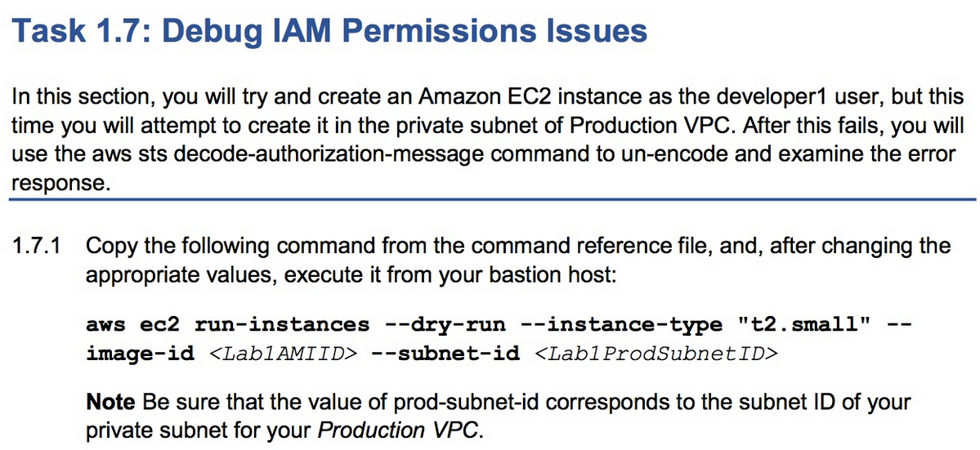 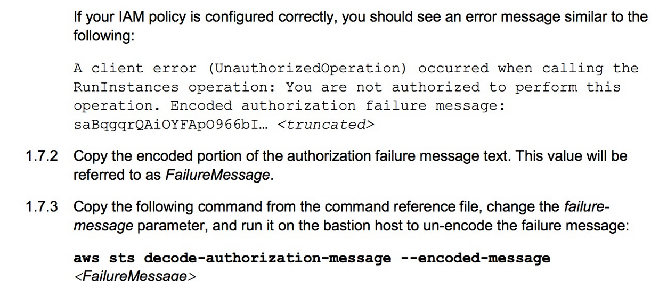 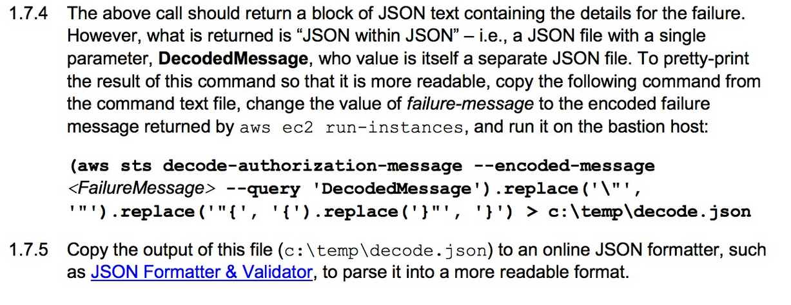 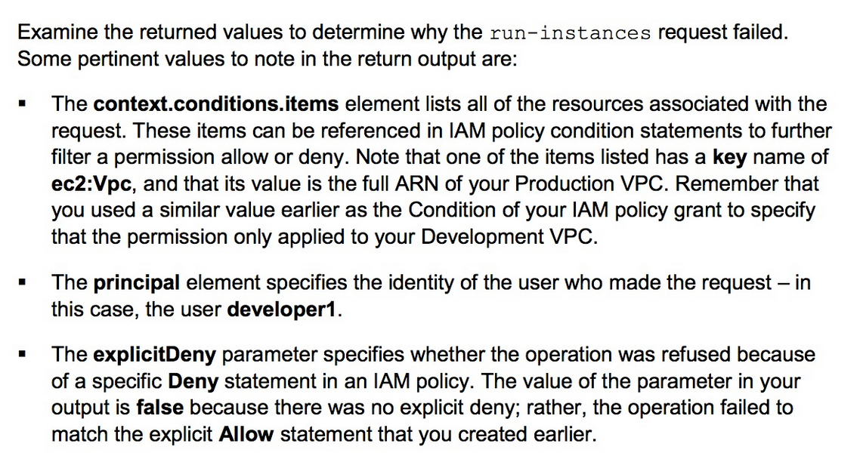 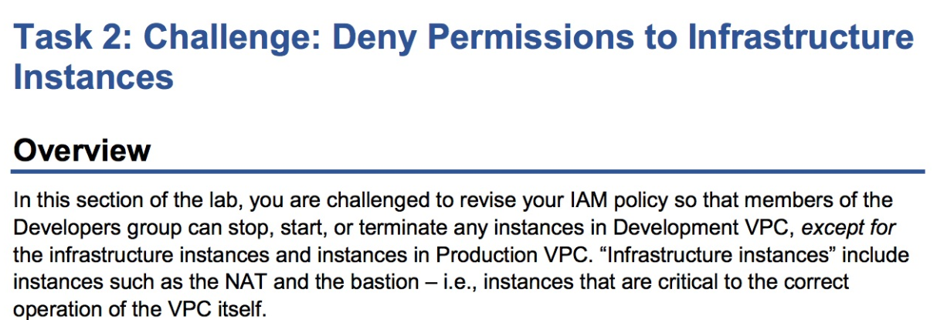 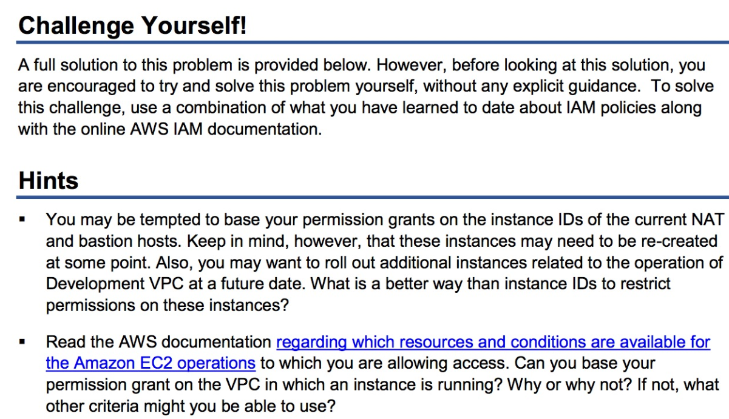  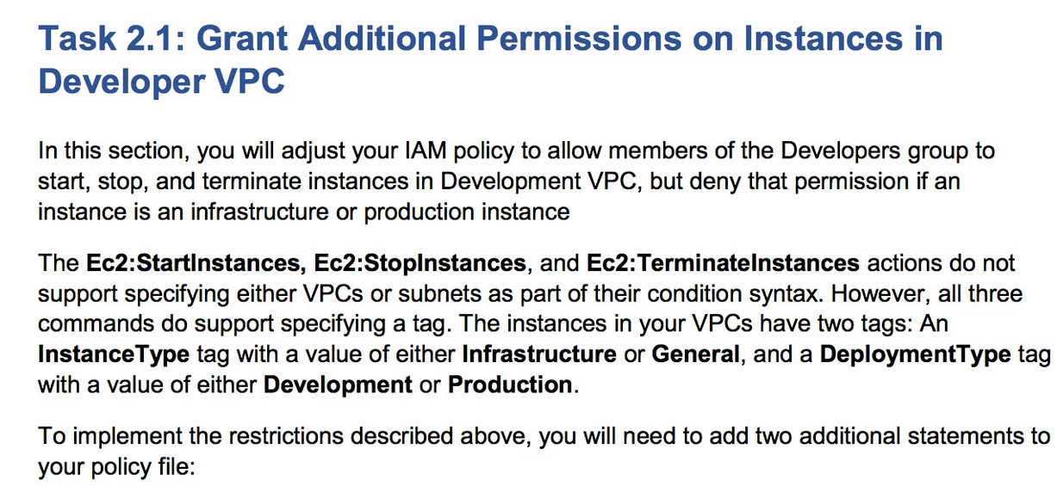 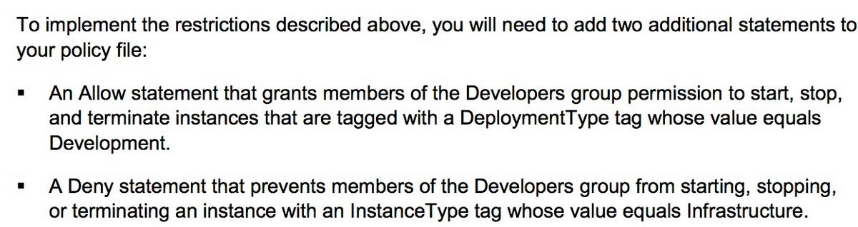 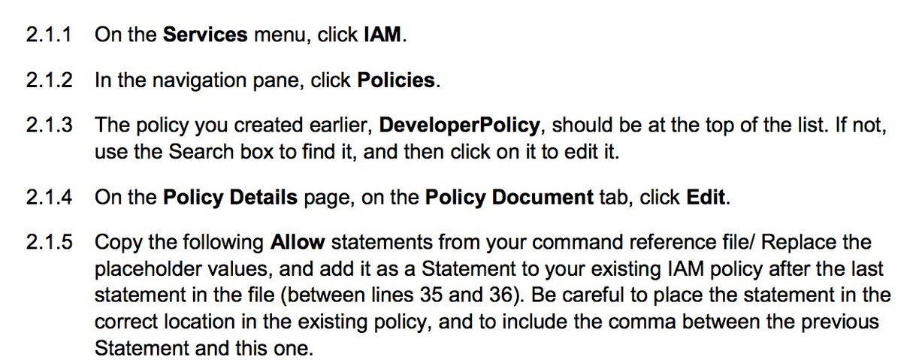 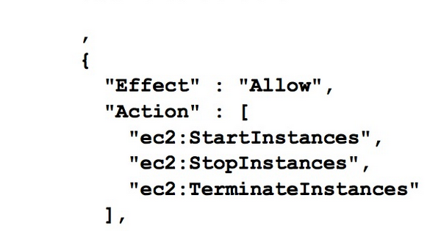 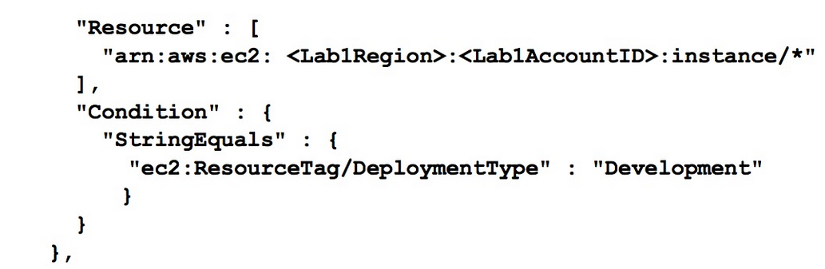

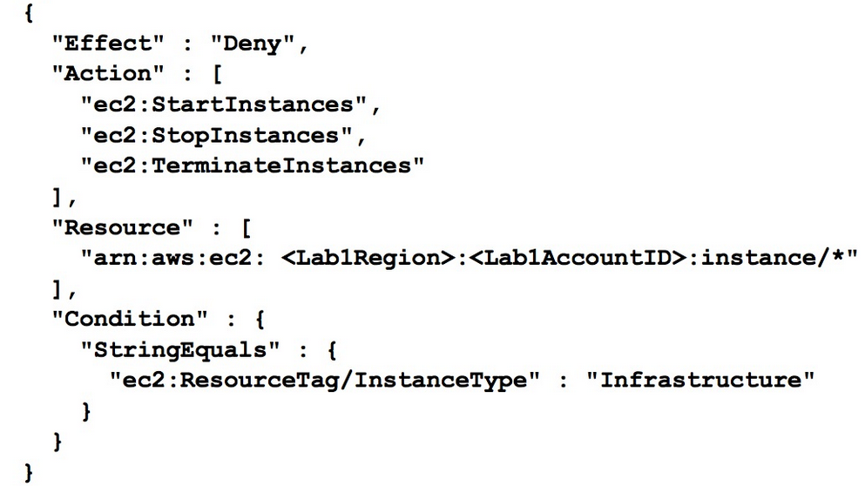 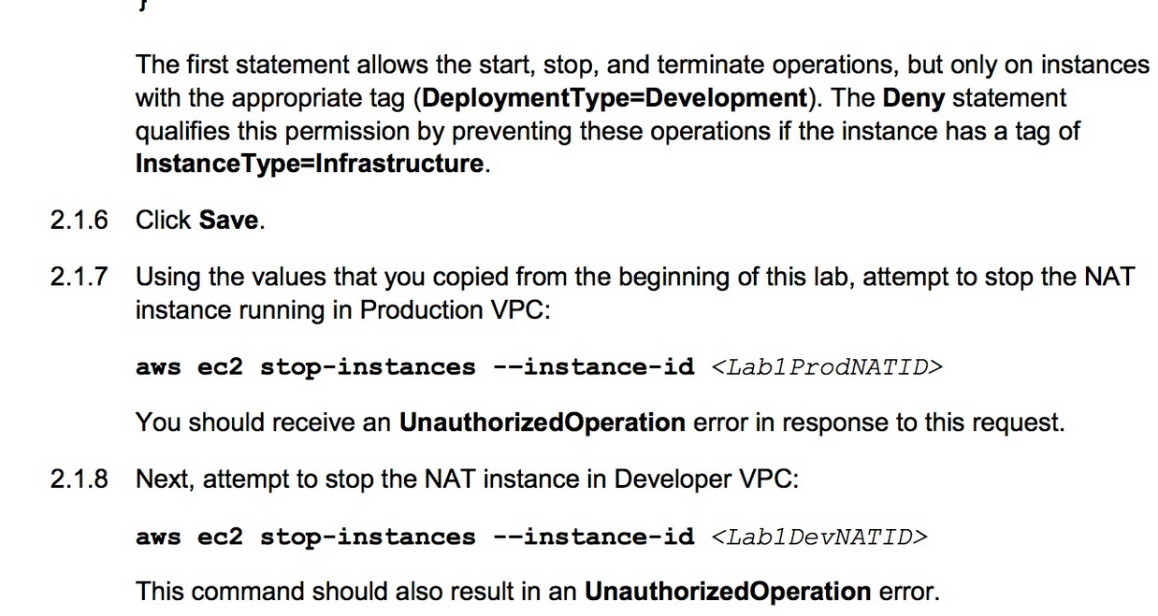  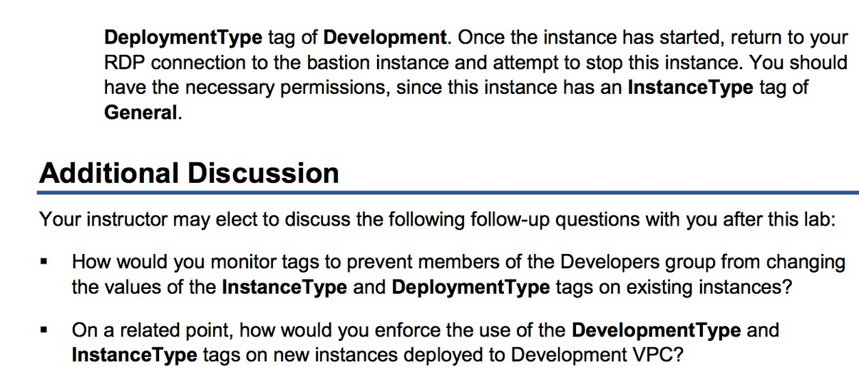 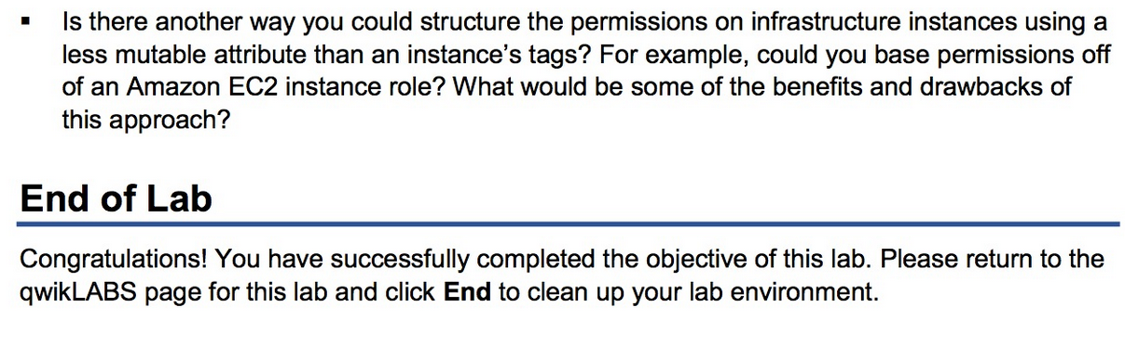

DevOps Engineering on AWS: Lab 1 - Configuring DevOps Roles on AWS - v1.6 (Windows)

==================================================================================================================

Using this command reference.

==================================================================================================================

1. Locate the section you need. Each section in this file matches a section in the lab instructions.

2. Replace items in angle brackets - < > - with appropriate values. For example, in this command you would replace the value - <JobFlowID> - (including the angle brackets) with the parameter indicated in the lab instructions:

elastic-mapreduce --list <JobFlowID>. You can also use find and replace to change bracketed parameters in bulk.

3. Do NOT enable the Word Wrap feature in Windows Notepad or the text editor you use to view this file.

++++1. Task: Restrict Developer Access to Production++++

==================================================================================================================

1.2 Create an Initial IAM Policy

==================================================================================================================

1.2.1 Copy the IAM policy

{

"Version" : "2012-10-17",

"Statement" : [{

"Sid" : "Stmt1425065597000",

"Effect" : "Allow",

"Action" : [

"ec2:RunInstances"

],

"Resource" : "arn:aws:ec2:<Lab1Region>:<Lab1AccountID>:subnet/\*",

"Condition" : {

"StringEquals" : {

"ec2:Vpc" : "arn:aws:ec2:<Lab1Region>:<Lab1AccountID>:vpc/<Lab1DevVPC>"

}

}

}, {

"Effect" : "Allow",

"Action" : "ec2:RunInstances",

"Resource" : [

"arn:aws:ec2:<Lab1Region>:<Lab1AccountID>:instance/\*",

"arn:aws:ec2:<Lab1Region>:<Lab1AccountID>:volume/\*",

"arn:aws:ec2:<Lab1Region>:<Lab1AccountID>:network-interface/\*",

"arn:aws:ec2:<Lab1Region>:<Lab1AccountID>:key-pair/\*",

"arn:aws:ec2:<Lab1Region>:<Lab1AccountID>:security-group/\*",

"arn:aws:ec2:<Lab1Region>::image/\*"

]

}, {

"Effect" : "Allow",

"Action" : ["sts:DecodeAuthorizationMessage"],

"Resource" : "\*"

}

]

}

==================================================================================================================

1.6 Test Developer Permissions

==================================================================================================================

1.6.10 Test permissions from bastion command line

aws ec2 run-instances --dry-run --instance-type "t2.small" --image-id <Lab1AMIID> --subnet-id <Lab1DevSubnetID>

==================================================================================================================

1.7 Debug IAM Permissions Issues

==================================================================================================================

1.7.1 Attempt to create an instance in the production VPC instead

aws ec2 run-instances --dry-run --instance-type "t2.small" --image-id <Lab1AMIID> --subnet-id <Lab1ProdSubnetID>

1.7.3 Decode the failure message

aws sts decode-authorization-message --encoded-message <FailureMessage>

1.7.4 Pretty-print the decoded authorization message

(aws sts decode-authorization-message --encoded-message <FailureMessage> --query 'DecodedMessage').replace('\"', '"').replace('"{', '{').replace('}"', '}') > c:\temp\decode.json

++++2. Challenge: Deny Permissions to Infrastructure Instances++++

==================================================================================================================

2.1 Grant Additional Permissions on Instances in Developer VPC

==================================================================================================================

2.1.5 Paste Allow statements into existing IAM policy

,

{

"Effect" : "Allow",

"Action" : [

"ec2:StartInstances",

"ec2:StopInstances",

"ec2:TerminateInstances"

],

"Resource" : [

"arn:aws:ec2:<Lab1Region>:<Lab1AccountID>:instance/\*"

],

"Condition" : {

"StringEquals" : {

"ec2:ResourceTag/DeploymentType" : "Development"

}

}

},

{

"Effect" : "Deny",

"Action" : [

"ec2:StartInstances",

"ec2:StopInstances",

"ec2:TerminateInstances"

],

"Resource" : [

"arn:aws:ec2:<Lab1Region>:<Lab1AccountID>:instance/\*"

],

"Condition" : {

"StringEquals" : {

"ec2:ResourceTag/InstanceType" : "Infrastructure"

}

}

}

2.1.7 Attempt to stop the NAT instance in Production VPC

aws ec2 stop-instances --instance-id <Lab1ProdNATID>

2.1.8 Attempt to stop the NAT instance in Development VPC

aws ec2 stop-instances --instance-id <Lab1DevNATID>

Â© 2017 Amazon Web Services, Inc. or its affiliates. All rights reserved.